**Task No. 1:** Banking Interface

Implement a command-line application using interface for a banking system.

Details: Students will create app where users can type commands to check balances, deposit, and withdraw money.

**Solution:**

import gradio as gr

class BankingSystem:

    def __init__(self):

        self.accounts = {}

    def create_account(self, account_number, initial_balance=0):

        self.accounts[account_number] = initial_balance

        return f"Account {account_number} created with initial balance ${initial_balance}"

    def check_balance(self, account_number):

        balance = self.accounts.get(account_number, "Account not found")

        return f"Balance for account {account_number}: ${balance}"

    def deposit(self, account_number, amount):

        if account_number in self.accounts:

            self.accounts[account_number] += amount

            return f"${amount} deposited into account {account_number}\n{self.check_balance(account_number)}"

        else:

            return "Account not found"

    def withdraw(self, account_number, amount):

        if account_number in self.accounts:

            if self.accounts[account_number] >= amount:

                self.accounts[account_number] -= amount

                return f"${amount} withdrawn from account {account_number}\n{self.check_balance(account_number)}"

            else:

                return "Insufficient funds"

        else:

            return "Account not found"

banking_system = BankingSystem()

def banking_interface(command, account_number=None, amount=None, initial_balance=None):

    if command == 'create':

        return banking_system.create_account(account_number, initial_balance)

    elif command == 'balance':

        return banking_system.check_balance(account_number)

    elif command == 'deposit':

        return banking_system.deposit(account_number, amount)

    elif command == 'withdraw':

        return banking_system.withdraw(account_number, amount)

    else:

        return "Invalid command. Please try again."

iface = gr.Interface(

    fn=banking_interface,

    inputs=[

        gr.Textbox(type="text", label="Command"),

        gr.Textbox(type="text", label="Account Number"),

        gr.Textbox(type="text", label="Amount/Initial Balance"),

        gr.Textbox(type="text", label="Withdrawal/Deposit Amount"),

    ],

    outputs=gr.Textbox(),

)

iface.launch()

**Output:**

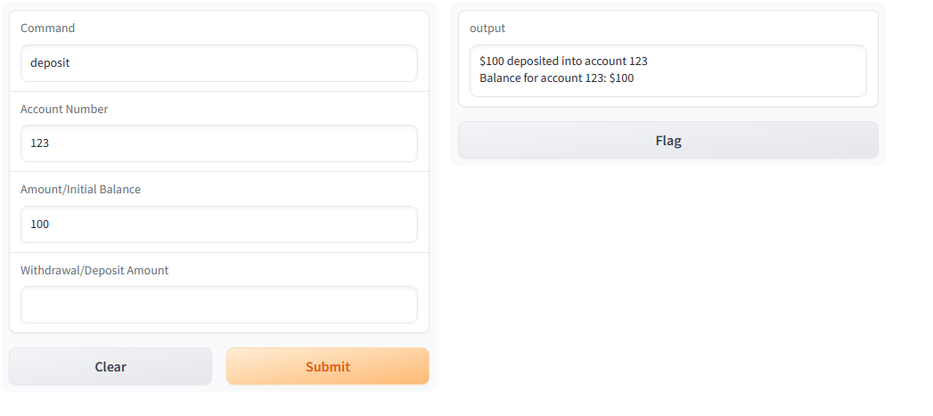

**Task No. 2:** Gradio Library Management System

Objective: Design a Gradio interface for managing a library system. Details: Using Gradio, students will develop a GUI for entering new books, searching the catalog, and managing borrowings.

**Solution:**

import gradio as gr

# Placeholder data structures to simulate a library catalog

library_catalog = []

borrowed_books = []

# Function to add a new book to the catalog

def add_book(title, author, ISBN):

    book = {'title': title, 'author': author, 'ISBN': ISBN}

    library_catalog.append(book)

    return f"Book '{title}' by {author} added to the catalog."

# Function to search the catalog based on the query

def search_catalog(query):

    results = [book['title'] for book in library_catalog if query.lower() in book['title'].lower()]

    return results if results else "No matching books found."

# Gradio Interface for adding a book

add_book_interface = gr.Interface(

    fn=add_book,

    inputs=["text", "text", "text"],

    outputs="text",

    live=True,

    title="Add a New Book to the Catalog"

)

# Gradio Interface for searching the catalog

search_catalog_interface = gr.Interface(

    fn=search_catalog,

    inputs="text",

    outputs="text",

    live=True,

    title="Search the Library Catalog"

)

# Launch Gradio Interfaces

add_book_interface.launch()

search_catalog_interface.launch()

**Output:**

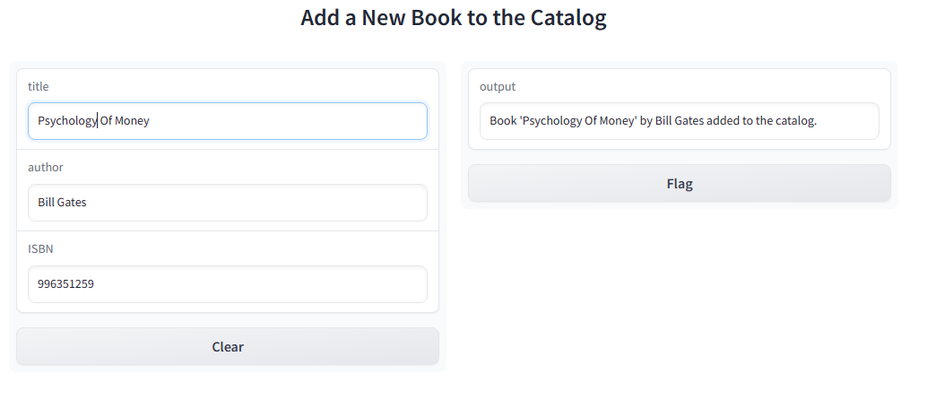

**Task No. 3:** Gradio Recursive File Search Interface

Objective: Create a Gradio interface that allows users to search files recursively.

Details: Students will develop a Gradio app that provides a user interface for specifying a directory and file type, then displays a list of all matching files found through recursive search.

**Solution:**

import os

import gradio as gr

def recursive_file_search(directory, file_type):

matching_files = []

for root, _, files in os.walk(directory):

for file in files:

if file.endswith(file_type):

matching_files.append(os.path.join(root, file))

return "\n".join(matching_files)

file_types = [".txt", ".pdf", ".jpg"] # Add more file types as needed

iface = gr.Interface(

fn=recursive_file_search,

inputs=[gr.Textbox(), gr.Dropdown(file_types)],

outputs=gr.Textbox(),

live=True,

title="Recursive File Search",

description="Enter a directory and select a file type to search recursively.",

examples=[["/path/to/directory", ".txt"]]

)

iface.launch()

**Output:**

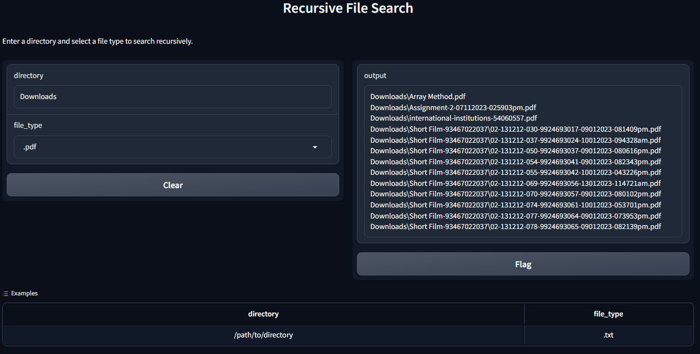

**Task No. 4:** Gradio-based Calculator

Objective: Build a calculator with a graphical user interface using Gradio.

Details: Students will use Gradio to create a web-based calculator that performs basic arithmetic operations and displays the results on the GUI.

**Solution:**

import gradio as gr

# Define the arithmetic operations

def add(a, b):

    return a + b

def subtract(a, b):

    return a - b

def multiply(a, b):

    return a * b

def divide(a, b):

    if b != 0:

        return a / b

    else:

        return "Cannot divide by zero"

# Define the Gradio interface

iface = gr.Interface(

    fn=add,  # You can choose any operation here: add, subtract, multiply, divide

    inputs=[

        gr.Number(label="Enter first number"),

        gr.Number(label="Enter second number"),

    ],

    outputs=gr.Textbox(),

    live=True,

    title="Simple Calculator",

    description="Perform basic arithmetic operations",

)

iface.launch()

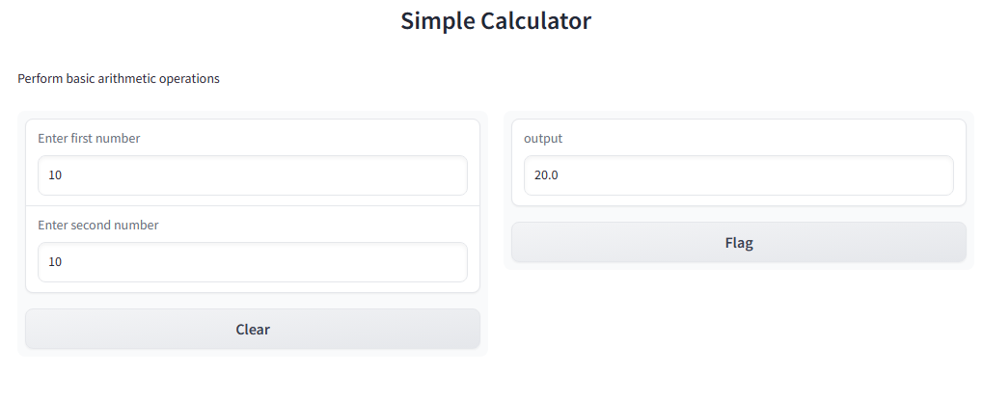**Output:**

**Task No. 5:** Binary Tree Traversal

Create a Python program that defines a binary tree as a recursive data type. Implement functions for in-order, pre-order, and post-order traversals of the binary tree. Test your program with a sample binary tree and display the results of each traversal.

**Solution:**

import gradio as gr

class TreeNode:

    def __init__(self, value):

        self.value = value

        self.left = None

        self.right = None

def in_order_traversal(node, result):

    if node is not None:

        in_order_traversal(node.left, result)

        result.append(node.value)

        in_order_traversal(node.right, result)

def pre_order_traversal(node, result):

    if node is not None:

        result.append(node.value)

        pre_order_traversal(node.left, result)

        pre_order_traversal(node.right, result)

def post_order_traversal(node, result):

    if node is not None:

        post_order_traversal(node.left, result)

        post_order_traversal(node.right, result)

        result.append(node.value)

def traverse_binary_tree(traversal_type):

    # Sample binary tree

    root = TreeNode(1)

    root.left = TreeNode(2)

    root.right = TreeNode(3)

    root.left.left = TreeNode(4)

    root.left.right = TreeNode(5)

    root.right.left = TreeNode(6)

    root.right.right = TreeNode(7)

    result = []

    if traversal_type == "In-order":

        in_order_traversal(root, result)

    elif traversal_type == "Pre-order":

        pre_order_traversal(root, result)

    elif traversal_type == "Post-order":

        post_order_traversal(root, result)

    return result

# Gradio Interface

iface = gr.Interface(

    fn=traverse_binary_tree,

    inputs="text",

    outputs="text",

    live=True,

    examples=[["In-order"], ["Pre-order"], ["Post-order"]]

)

iface.launch()

**Output:**

**Task No. 6:** Directory Structure Analysis

Design a program that models a directory structure using a recursive data type. Each node in the structure represents either a file or a directory. Implement a function that calculates the total size of the directory, considering the sizes of all files and subdirectories. Test your program with a sample directory structure and display the total size.

**Solution:**

import gradio as gr

import os

def calculate_total_size(directory_path):

try:

total_size = sum(os.path.getsize(os.path.join(dirpath, filename))

for dirpath, dirnames, filenames in os.walk(directory_path)

for filename in filenames)

return f"Total size of the directory '{directory_path}': {total_size} bytes"

except FileNotFoundError:

return f"Directory '{directory_path}' not found."

except PermissionError:

return f"Permission denied for directory '{directory_path}'."

except Exception as e:

return f"An error occurred: {e}"

iface = gr.Interface(

fn=calculate_total_size,

inputs=gr.Textbox("text", label="Enter directory path:"),

outputs="text",

live=True

)

iface.launch()

**Output:**

